How to count checkboxes in Google Sheets

In Google Sheets, [**checkboxes**](https://spreadcheaters.com/how-to-use-checkboxes-in-google-sheets/) are a type of data validation that allows users to select or deselect a binary choice. They are represented by small square boxes that can be checked or unchecked by clicking on them. Checkboxes are commonly used in spreadsheets to track tasks, mark completion status, or create interactive forms.

The dataset provides basic information about employees, including their unique identifiers, names, ages, genders, the departments they belong to and their attendances in the form of check boxes. In today’s tutorial, we will learn how to count the ticked, unticked and total number of check boxes.

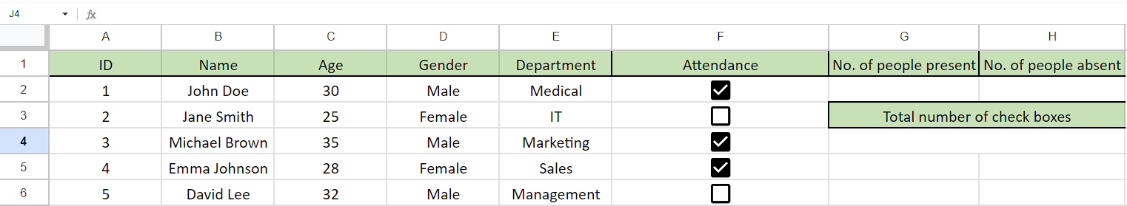

## Case 1 – Counting the ticked check-boxes

## Step 1 – Selecting the cell

* Firstly, select any cell in which you want to calculate the number of **ticked check-boxes.**
* In this cell, we will apply the **COUNTIF Formula** to get **total** number **of ticked check-boxes.**



## Step 2 – Writing the formula

* In the selected cell **type “=”** (without quotes) and then write **COUNTIF** in the selected cell and select the **COUNTIF Function** by pressing **tab button** on your keyboard.
* Then, **select the range of cells** in which the **checkboxes are present.** For example, we’ve selected the range of cells (**F2:F6**).
* After doing that, **press comma (,)** button on your keyboard and then **write TRUE.**
* Now, your formula would look like this,

=COUNTIF(F2:F6,TRUE



## Step 3 – Implementing the formula

* Then, **close the parenthesis** and **press Enter.**
* After that, the **result would appear** on the screen which is **3** and as you can see the **3 checkboxes are ticked** and the answer is according to it.



## Case 2 – Counting the unticked check-boxes

## Step 1 – Selecting the cell

* First of all, select any vacant cell in which you want to calculate the number of **unticked check-boxes.**
* In this cell, we will use the **COUNTIF Formula** in this cell to get **total** number of **unticked check-boxes.**



## Step 2 – Writing the formula

* Type **"=" (without quotes)** in the selected cell, **followed by "COUNTIF".**
* Press the **Tab button** on your keyboard to select the **COUNTIF Function.**
* **Select the range of cells** where the **checkboxes are located.** For example, if the checkboxes are in cells **F2 to F6**, select that range.
* Press the **comma (,)** **button** on your keyboard.
* Type **"FALSE" (without quotes)** after the comma.
* Your formula should now look like this:

=COUNTIF(F2:F6, FALSE



## Step 3 – Implementing the formula

* **Close the parenthesis** and **press Enter.**
* The result will appear on the screen, indicating the **number of unticked checkboxes.** For example, if the **result is 2**, it means that **2 checkboxes are unticked.**



## Case 1 – Counting the ticked and unticked check-boxes

## Step 1 – Selecting the cell

* First of all, select any vacant cell in which you want to calculate **the total number check-boxes.**
* In this cell, we will use the **SUM Function** to find **total number of check-boxes.**



## Step 2 – Writing the formula

* Firstly, write **= (equal sign)** in the selected cell.
* Then, type **SUM** and select the **SUM Function** by using **tab button** on your keyboard**.**
* After that, **select or enter** the **name of cell** in which result of **total ticked check boxes** is present. For example, it is **cell G2** in our case.
* Then, press the **comma (,) button** and then **select or enter the name of cell** in which the **result of total unticked checkboxes** is present. For example, it is **cell H2** in our case.
* Now your formula would look like this,

**=SUM(G2,H2**



## Step 3 – Implementing the formula

* After writing the formula, **close the parenthesis** and **press Enter.**
* The result would appear in the cell which is **5** and as we can see that **total number of checkboxes is 5** which is **according to the answer.**

